**LAB 14**

**Configuring IPv4 subnets**

1. In a previous lab, you learned how to configure a (Cisco) router: make some initial (security) configurations and assign IP address to its interfaces so it can route data traffic between different networks (with different netIDs).

In that lab (“Basic configuration of a Cisco router”), we used the topology below and we told you what IP addresses to use during configuration.

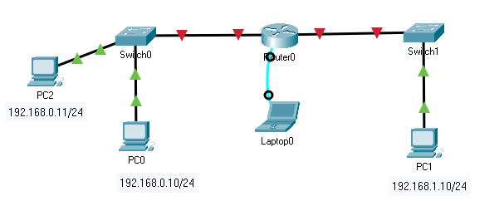

1. Now, we will start from the same topology, but now you have to calculate yourself what IP addresses to use (and configure these on the devices). Thus you can consider this lab as a recap of both IP addressing and network configuration. Open the “Lab 15 – Configuring IPv4 subnets.pka” file. All devices are reset to their default settings, no IP address have been assigned yet. Follow the next steps to determine and set all IP addresses and related information.

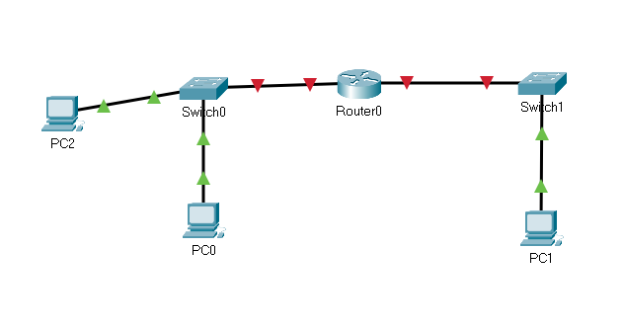

1. In this scenario, we will use the network address 172.20.0.0/16, which we split in 2 equally large subnets: subnet 0 and subnet 1. What is the network address of each of these subnets in prefix notation? And what is the subnet mask in dotted decimal notation?

* Subnet 0: 172.20.0.0/17
* Subnet 1: 172.20.128.0/17
* Netmask : 255.255.128.0

1. We will use subnet 0 on the left side of the router and subnet 1 is the subnet on the right side of the router.

Assign the following IPv4 addresses to the PCs:

* IP address PC0 = first host address of subnet 0
* IP address PC2 = second host address of subnet 0
* IP address PC1 = first host address of subnet 1

Hint: don’t forget to specify the correct subnet mask.

1. Now, ping from PC0 to PC2. This should work because these PCs belong to the same network. (Same networkID and connected via switch(es).)
2. Now, ping from PC0 to PC1. This will not work because these PCs do not belong to the same network. (Different networkID and routers in between.)
3. To have successful communication between different networks, we still need to configure our router. Configure the router interfaces using the CLI as follows:

* IP address left interface router = last host address of subnet 0
* Description for this IP configuration = left interface
* IP address right interface router = last host address of subnet 1
* Description of this IP configuration = right interface

Reminder: router interfaces are not active by default

1. Save your current configuration file to startup-config (in NVRAM memory). Check the contents of the NVRAM memory with ***dir nvram:*** to check if your previous command was successful.
2. Now you still have to make one additional change to all of your PCs in order for these to be able to communicate across different networks. Make sure all PCs can ping each other.

Hint: If you don’t know, have a look at the previous lab “Basic configuration of a Cisco router” where we told you what to configure to make the ping from PC0 to PC1 work.

1. Use a command to see the contents of the route table of Router0.

Provide the network addresses of the networks for which a route is provided in that route table. Note that these networks were automatically added in the route table because of the IP addresses you assigned to the router’s interfaces.

172.20;0.0/17 and 172.20.128.0/17

🡪 other entries have codeletter L

Is there a default route in the route table? How do you know this?

There is no default route table in the list. You can see ‘Gateway of last resort is not set’.

Can that router forward a package intended for the host with IP address 172.21.1.1/16? Why (not)?

No. There is no default route set.

1. Optionally: as a recap exercise there are still a few things you could do to make your network setup complete (well, at least with the things you know so far):
   1. protect your Router0 console access and Privileged EXEC mode
   2. enable and protect vty line access on Router0 for remote management
   3. protect your Switch0 & Switch1 console access and Privileged EXEC mode
   4. provide Switch0 & Switch1 with an IP address on a virtual interface. You can use the one but last IP address of each subnet to this end.
   5. specify on Switch0 & Switch1 what default gateway they can use to be accessible from within other networks.
   6. enable and protect vty line access on Switch0 & Switch1 for remote management via their IP address

Hint: have a look at lab “Basic configuration of a Cisco switch” and “Basic configuration of a Cisco router” if you forgot some things.

1. Save your pka file and upload it via Leho.